INVENTION DISCLOSURE FORM

1. Details of the Invention

a. Title of the invention | QR-Based Cattle Management System with AI-Driven Health Monitoring and Composite Health Deviation Index (CHDI)

b. Field of the invention | Artificial Intelligence, Machine Learning, and Precision Livestock Farming (Animal Husbandry Technology)

c. Stage of development
☐ Idea only ☐ Proof of concept ☒ Prototype ☒ Tested ☐ In use/deployed

d. Is the invention based on | ☒ Product | ☒ Process/Method | ☐ Composition | ☐ Other

e. What is/are the Novel/New aspects of the invention? What is the inventive step?
Sensor-Optional, QR-Based Health Identification and Data Capture
Existing precision-livestock systems rely on expensive wearable IoT hardware (ear tags, collars, boluses) fitted to every animal. This invention identifies each animal through a low-cost, durable QR tag and accepts manually logged or QR-scan-linked data (weight, feed intake, activity, milk yield), removing the hardware cost barrier for smallholder dairy farmers while remaining sensor-compatible.
Personalized, Per-Animal Physiological Baseline
Rather than comparing an animal against generalized herd or breed averages, the system constructs a rolling statistical baseline unique to each animal from its own historical data, accounting for natural physiological variations across age, parity, and lactation cycles.
Composite Health Deviation Index (CHDI) Scoring
Deviations across multiple vitals (weight, feed intake, activity, milk yield, and scan frequency) are integrated into a single Composite Health Deviation Index using a covariance-aware distance calculation, capturing the natural correlation geometry of physiological signals.
Confidence-Aware Decision Abstention Mechanism
When historical records are insufficient (e.g., newly registered animals) or signal variance is unstable, the system explicitly withholds a verdict rather than issuing potentially unreliable classifications, drastically minimizing false alarms.
Veterinarian-Verified Active Feedback Loop
Clinical confirmation or override of each system-flagged case by attending veterinarians is captured as labeled outcome data to periodically retrain a supervised classifier, allowing predictive accuracy to continuously improve from verified field outcomes.
Regional Multi-Farm Outbreak Early-Warning Aggregation
Individual health deviations are aggregated across farms within a geographic region. Correlated deviation patterns across multiple animals and discrete holdings automatically trigger regional alerts for early-stage disease outbreak containment.

f. Is there any prior art for this invention?
Haladjian et al. (2018). “A Wearable Sensor System for Lameness Detection in Dairy Cattle,” Multimodal Tech. & Interaction, 2(2), 27.
Uses a wearable motion sensor attached to the cow for lameness detection. Limitations: Limited strictly to lameness and requires per-animal wearable hardware; lacks QR/sensor-independent operation, composite multi-signal CHDI scoring, confidence abstention, and regional outbreak aggregation.
Suchak et al. (2026). “IoT-Based Smart Cattle Health Monitoring System Using Machine Learning for Real-Time Anomaly Detection,” LNNS, Vol. 1463.
Covers IoT- and machine-learning-based cattle monitoring. Limitations: Fully reliant on physical sensor hardware; lacks the proposed low-cost QR workflow, per-animal CHDI covariance scoring, confidence abstention, or veterinarian-feedback retraining.
Kasuga & Kasuga (2017). “Livestock Management System,” JP6203238B2.
Describes QR-code tags attached to livestock matched with a management database. Limitations: Only provides static identification lookups; does not disclose automated AI health deviation scoring, CHDI baseline forecasting, confidence abstention, or predictive triage.
Subramanian et al. (2024). “IoT-Based Cattle Health and Heat Monitoring System,” WO2024009326A1.
Describes wearable collar units using sensor data for activity and health alerts. Limitations: Dependent on body-worn collar devices; lacks an optical sensor-independent workflow, regularized CHDI metric, and clinical active learning.

g. General overview of the invention, including specific keywords and phrases:
The present invention relates to an AI-driven cattle health monitoring and management system that identifies each animal through a low-cost optical QR tag and evaluates health using a Composite Health Deviation Index (CHDI) computed from manually logged and QR-scan-linked data, without requiring wearable sensors. The system establishes a personalized rolling baseline for each animal from its own historical records (weight, feed intake, activity, and milk yield), computes real-time deviation from that baseline using a covariance-aware distance method, and expresses the result as a single composite score with an associated confidence level. Cases falling below healthy thresholds or during formative baseline periods trigger a confidence-aware abstention mechanism, withholding speculative labels. Flagged cases are routed to veterinarians with plain-language factor summaries; clinical confirmations or overrides are captured to periodically retrain a supervised classifier. Furthermore, deviations are aggregated across local farms to detect regional disease outbreaks early. The system operates via role-specific web interfaces for Farmers, Veterinarians, and Administrators.
Specific Keywords and Phrases Pertaining to the Invention:
• QR-Based Animal Identification
• Sensor-Optional Health Monitoring
• Personalized Physiological Baseline
• Composite Health Deviation Index (CHDI)
• Covariance-Aware Anomaly Detection
• Confidence-Aware Decision Abstention
• Veterinarian Feedback Loop / Active Learning
• Regional Outbreak Early-Warning Aggregation
• Explainable AI for Animal Health
• Precision Livestock Farming

h. How the invention is more beneficial or feasible over the prior art:
1. Total elimination of wearable hardware cost barrier
Prior systems require expensive wearable hardware ($80-$150 per animal), which is unaffordable for smallholders. This invention functions from weather-resistant optical QR tags costing under $0.50, removing capital barriers while remaining sensor-compatible.
2. Personalized rolling baseline rather than population averages
Prior art evaluates cattle against generalized breed or herd norms that trigger high false alarms due to natural biological variations. This invention builds an individualized rolling baseline strictly from the animal's own data history.
3. Covariance-aware multivariate scoring
Rather than monitoring single vitals or assigning arbitrary heuristic weights, this invention combines multi-signal deviations into a single score using a covariance-aware distance calculation that reflects how vitals naturally move together.
4. Explicit abstention reduces false alarms
Unlike systems that force classifications on minimal data, this invention withholds verdicts when data volume is insufficient, preserving farmer trust and preventing unnecessary clinical costs.
5. Continuous clinical verification improves accuracy
Most prior art operates as a static rule detector. This invention captures veterinarian confirm/override decisions as labeled data to retrain the classifier on real field outcomes.
6. Multi-farm population-level outbreak radar
Extends individual cattle tracking across neighboring farms in a region, automatically alerting authorities on correlated health deviations indicative of infectious outbreaks.

i. Detailed explanation of the invention:
The invention comprises the following interoperating modules:
1. Cattle Identification & Registration Module
Captures identity details (tag ID, breed, gender, date of birth, purpose), generates a unique QR token linked to the animal's cloud profile, and initializes health status in an explicit ABSTAIN state.
2. Multi-Signal Data Logging Module
Accepts timestamped milk yield, feed intake, activity score, body weight, and scan frequency via mobile optical QR scanning and farmer manual entry, with optional IoT input compatibility.
3. Personalized Baseline Forecasting Module
Computes an expected rolling mean and covariance baseline strictly from the animal's own historical entries once a minimum threshold (N >= 7 entries) is achieved.
4. Composite Health Deviation Index (CHDI) Scoring Module
Computes multivariate deviation from baseline using a regularized Mahalanobis distance metric: D_M = sqrt((x - μ)^T * (Σ + λ*I)^(-1) * (x - μ)), mapped to a bounded score (0–100) and categorized into Normal (>=80), Watch (60–79), and At-Risk (<60) bands.
5. Confidence-Aware Abstention Module
Evaluates historical sample count and signal stability. If entries are insufficient or variance is ill-conditioned, the system returns an ABSTAIN state, avoiding false positive alerts.
6. Two-Tier Explainability Module
Ranks signal-level contribution to deviations, displaying intuitive plain-language summaries for farmers and complete multidimensional breakdown charts for veterinarians.
7. Veterinarian Case Management & Active Feedback Module
Automatically routes cases entering Watch or At-Risk bands to assigned regional veterinarians, capturing clinical diagnosis, treatments, and a binary Confirm/Override label as ground-truth training data.
8. Adaptive Classifier Retraining Module
Periodically retrains a supervised classifier using accumulated veterinarian-confirmed outcomes to continuously refine health-risk prediction accuracy.
9. Regional Outbreak Aggregation Module
Aggregates recent deviations across discrete farms within a geographic cluster. Correlated multi-farm anomalies exceeding a density threshold trigger an emergency regional disease alert.
End-to-End Operational Flow:
1. Farmer registers animal and attaches optical QR tag; initial record initialized in ABSTAIN state.
2. Farmer logs milk yield, feed intake, and activity via mobile camera scan and app interface.
3. System establishes rolling baseline once minimum entries (N >= 7) accumulate.
4. CHDI module computes ongoing deviation, confidence score, and clinical status.
5. Watch and At-Risk cases route automatically to assigned veterinarians with explainability summaries.
6. Veterinarian examines animal, administers care, and records clinical confirmation or override.
7. Retraining module incorporates clinical feedback to continuously update model accuracy.
8. Outbreak engine cross-correlates multi-farm data to alert on potential contagious outbreaks.
Example Scenario:
A dairy cow's milk yield and daily feed intake trend downward over three consecutive days while its body weight and activity remain normal. The CHDI module detects this correlated bivariate deviation and places the animal in the 'Watch' band, identifying milk yield drop as the dominant factor. An automated clinical case is routed to the regional veterinarian, who reviews the trajectory, visits the animal, diagnoses early subclinical ketosis, and confirms the flag. This verified outcome is archived to refine future early detection, while the cow receives prompt care before severe lactation loss occurs.

j. Provide Drawings, if any.
1. Cattle Identification & Registration Module  Captures animal identity details and generates a unique QR token per animal; derives age-group and initializes the CHDI record in an abstain state. | 2. Multi-Signal Data Logging Module  Records timestamped weight, feed, activity, milk-yield, and QR-scan data, each tagged with its source (manual, QR-scan, or optional sensor). | 3. Personalized Baseline & CHDI Scoring Module  Builds a per-animal expected-value baseline and computes a composite, covariance-aware deviation score with an associated confidence level.
4. Explainability & Abstention Module  Ranks signal-level contribution to the score for farmer/vet display, and withholds a verdict when historical data is insufficient. | 5. Veterinarian Case & Feedback Module  Routes flagged cases to the relevant veterinarian by region, captures diagnosis and confirm/override decisions as labelled outcome data. | 6. Regional Outbreak Aggregation Module  Aggregates individual deviations across farms within a region and triggers alerts on correlated multi-farm health events.
The invention is illustrated by the following representative system architecture and operational workflow drawing:
FIGURE 1: SYSTEM ARCHITECTURE AND OPERATIONAL WORKFLOW (100)
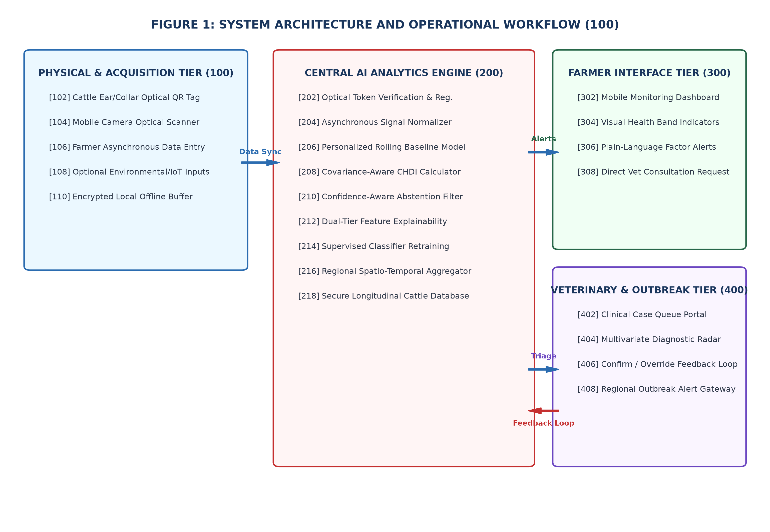
Descriptive of Numerical Labeling:
• 100 - Physical & Acquisition Tier: Includes cattle optical QR tag (102), mobile camera scanner (104), farmer manual entry interface (106), optional IoT inputs (108), and local offline buffer (110).
• 200 - Central AI Analytics Engine: Houses token verifier (202), signal normalizer (204), rolling baseline model (206), covariance-aware CHDI calculator (208), confidence abstention filter (210), two-tier explainability engine (212), classifier retraining pipeline (214), regional aggregator (216), and secure database (218).
• 300 - Farmer Interface Tier: Provides mobile monitoring dashboard (302), visual health status bands (304), plain-language factor alerts (306), and direct vet consultation requests (308).
• 400 - Veterinary & Outbreak Tier: Provides clinical case queue (402), multivariate diagnostic radar (404), confirm/override feedback loop (406), and regional outbreak alert gateway (408).

2. Disclosure

a. Has the invention ever been shown or used in public? | ☐ Yes ☒ No

If yes, Where / When | Where: ________________________ When: ________________________

b. Was any Confidentiality Agreement signed regarding the invention? | ☐ Yes ☒ No

c. Has this invention been publicly disclosed (e.g., paper presentation)? If yes, provide details on title of publication, or presented, Date of disclosure, Conference /Journal (Attach copies or drafts if available) | ☐ Yes ☒ No

3. Foreign Patent Protection

a. Do you intend to pursue International Patent protection? | ☐ Yes ☒ No

4. Funding and Sponsorship

1. Was this invention developed with external funding | No

2. Funding Agency / Sponsor | N/A

3. Grant or Contract number | N/A

4. Principal Investigator (PI) / Faculty Project Supervisor | [Faculty Guide / Project Supervisor Name], Department of AI & DS, Sona College of Technology, Salem

5. Are there any third-party obligations (collaborations, industry partners)? | No

5. Commercial Potential

1. Potential applications / Industries | Smallholder dairy farming, rural dairy cooperatives (e.g., Aavin, Amul), commercial herd management software, veterinary telemedicine portals, livestock micro-insurance underwriting, and government animal health monitoring programs.

2. Known competing technologies | Wearable IoT sensor systems (ear tags, collars, boluses), RFID identification systems without AI analytics, manual paper records, and general-purpose herd databases without multivariate health scoring.

3. Companies/organizations that may be interested in licensing this technology | National Dairy Development Board (NDDB), State Milk Federations, agritech startups (Stellapps, MooFarm, Prompt Dairy Tech), livestock insurance providers, and Department of Animal Husbandry and Dairying (DAHD), Govt. of India.

6. Inventorship Declaration

I/we declare that the information provided in this form is accurate and complete to the best of my/our knowledge. I/we agree to assign rights in this invention to Sona College of Technology, in accordance with institutional policy.

 | Inventor 1 | Inventor 2
a. Full Name | Sabari Karthick A | Sivanarasimman S
b. Designation & Department | Final-Year Student, Artificial Intelligence and Data Science | Final-Year Student, Artificial Intelligence and Data Science
c. Signature | _______________________ | _______________________
d. Date | _______________________ | _______________________

 | Inventor 3 | Inventor 4 (Faculty Guide)
a. Full Name | Sujeeth Y R | [Faculty Guide / Project Supervisor Name]
b. Designation & Department | Final-Year Student, Artificial Intelligence and Data Science | [Designation, e.g. Assistant Professor],  Department of Artificial Intelligence and Data Science
c. Signature | _______________________ | _______________________
d. Date | _______________________ | _______________________

Authorized Person - Name | Dr. [Head of Department / Dean R&D Name]
Designation | Head of Department (AI & DS) / Dean (R&D) / IPR Coordinator, Sona College of Technology
Signature | ________________________
Date | ________________________

Office use only
Disclosure number | SCT/CIPR/IDF/2026/______
Date received | ____ / ____ / 2026
Next steps | ☐ Approved for Prior Art Search ☐ Recommended for Filing ☐ Revision Required

